

East West University

Department of Computer Science & Engineering

**Course Title:** Database System

**Course Code:** CSE301  
**Experiment No:** 08

**Semester:** Fall, 2015

**Section:**01

**Submitted By:**

S. M. Amirul Islam

ID: 2013-1-60-048

In this lab we learn the basic ideas of the database management system, and learn about Cartesian product of database and also learn about join operations. Cartesian product generates every possible pair with all attributes from both given relations. Natural join matches tuples with the same values for all common attributes and retains only copy of each common column. Outer join is an extension of the join operation that avoids loss of information. Computes the join and then adds tuples from one relation that does not match tuples in the other relation to the result of the join. We use left outer join, right outer join, full outer join.

**QUESTION** – Create this 4 Tables   
(Borrower – Loan – Depositor – Customer – Account) –   
  
BORROWER

|  |  |
| --- | --- |
| Loan_no | customer_id |
| 245 | 105 |
| 310 | 925 |
| 356 | 820 |
| 450 | 820 |

createtable borrower(

loan_no int,

cid int

)

createprocedure xyz(@a int,@b int)

as

begin

insertinto borrower values(@a,@b)

end  
  
  
  
exec xyz 245,105

exec xyz 310,925

exec xyz 356,820

exec xyz 450,820

select*from borrower

LOAN

|  |  |  |
| --- | --- | --- |
| Loan_no | amount | Branch_name |
| 245 | 10000 | AB |
| 310 | 15000 | BD |
| 350 | 8000 | BD |
| 450 | 7000 | CD |

createtable loan(

loan_no int,

amount int,

branch_name varchar(20)

)

createprocedure ad(@a int,@b int,@c varchar(20))

as

begin

insertinto loan values(@a,@b,@c)

end

exec ad 245,10000,'AB'

exec ad 310,15000,'BD'

exec ad 350,8000,'BD'

exec ad 450,7000,'CD'

select*from loan

DEPOSITOR

|  |  |
| --- | --- |
| Acc_no | Customer_id |
| 101 | 307 |
| 103 | 925 |
| 106 | 820 |

createtable depositor(

acc int,

cid int

)

createprocedure ac(@a int,@b int)

as

begin

insertinto Depositor values(@a,@b)

end

exec ac 101,307

exec ac 103,925

exec ac 106,820

select*from Depositor

CUSTOMER

|  |  |  |
| --- | --- | --- |
| Customer id | name | Address |
| 105 | Asif | Dhaka |
| 925 | Ana | Sylhet |
| 820 | Dona | Raj |
| 207 | Alif | Bogra |

createtable customer(

cid int,

namevarchar(20),

address varchar(20)

)

createprocedure za(@a int,@b varchar(20),@c varchar(20))

as

begin

insertinto customer values(@a,@b,@c)

end

exec za 105,'Asif','Dhaka'

exec za 925,'Ana','sylhet'

exec za 820,'Dona','Raj'

exec za 207,'Alif','Bogra'

select*from customer

ACCOUNT

|  |  |  |
| --- | --- | --- |
| Acc_no | balance | Branch_name |
| 101 | 20000 | BD |
| 103 | 50000 | CD |
| 206 | 70000 | AD |

createtable Account(

acc int,

balance int,

branch_name varchar(20)

)

createprocedure ab(@a int,@b int,@c varchar(20))

as

begin

insertinto Account values(@a,@b,@c)

end

exec ab 101,20000,'BD'

exec ab 103,50000,'CD'

exec ab 206,70000,'AD'

select*from Account

**#1 Question**  
Show the customer id who have both loan and account.

**Answer**  
select borrower.cid from borrower join depositor on borrower.cid=depositor.cid

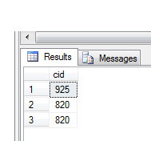

**#2 Question**  
Show the account no of customer who lives in Dhaka.

**Answer**  
  
select depositor.acc from depositor join customer on depositor.cid=customer.cid where customer.address='Dhaka'

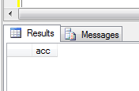

**#3 Question**  
Show the customer name who have loan.

**Answer**  
  
select customer.name from customer join borrower on borrower.cid=customer.cid

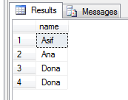

**#4 Question**  
Show the customer name who have account.

**Answer**  
  
select customer.name from customer join depositor on depositor.cid=customer.cid

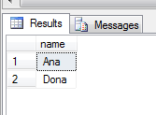

**#5 Question**  
Show the customer address who have loan.  
**Answer**  
  
select customer.addressfrom customer join borrower on borrower.cid=customer.cid

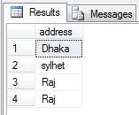

**#6 Question**  
Show the customer address who have account.

**Answer**  
  
select customer.name from customer join depositor on depositor.cid=customer.cid

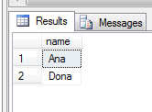

**#7 Question**  
Show the account information of customer who lives in Dhaka.

**Answer**  
  
select Account.acc,Account.balance,Account.branch_name from Account join depositor on Account.acc=depositor.acc join customer on customer.cid=depositor.cid where customer.address='Dhaka'

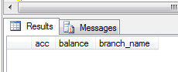

**#8 Question**  
Show the loan information of customer who lives in Sylhet.

**Answer**  
  
select loan.loan_no,loan.amount,loan.branch_name from loan join borrower on borrower.loan_no=loan.loan_no join customer on borrower.cid=customer.cid where customer.address='Sylhet'

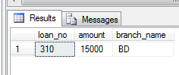

**#9 Question**  
Show the customer name of bd branch.

**Answer**  
  
select customer.name from customer join borrower on borrower.cid=customer.cid join loan on borrower.loan_no=loan.loan_no where loan.branch_name='BD'

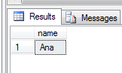

**#10 Question**  
Show the inner join, left outer join, right outer join, full outer join of depositor and customer table.

**Answer**  
select*from depositor innerjoin customer on depositor.cid=customer.cid

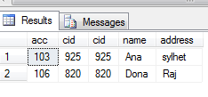

select*from depositor leftouterjoin customer on depositor.cid=customer.cid

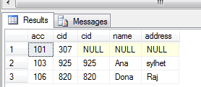

select * from depositor right outer join customer on depositor.cid=customer.cid

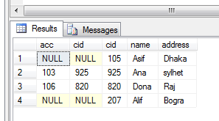

select * from depositor full outer join customer on depositor.cid=customer.cid

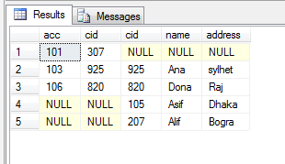

Discussion

In this lab we learn the

1. Basic ideas of the database management system
2. Learn Cartesian product of database and
3. Also learn about join operations.